COINS-Constantine I (306-337)-AE3-Trier-Altar with globe

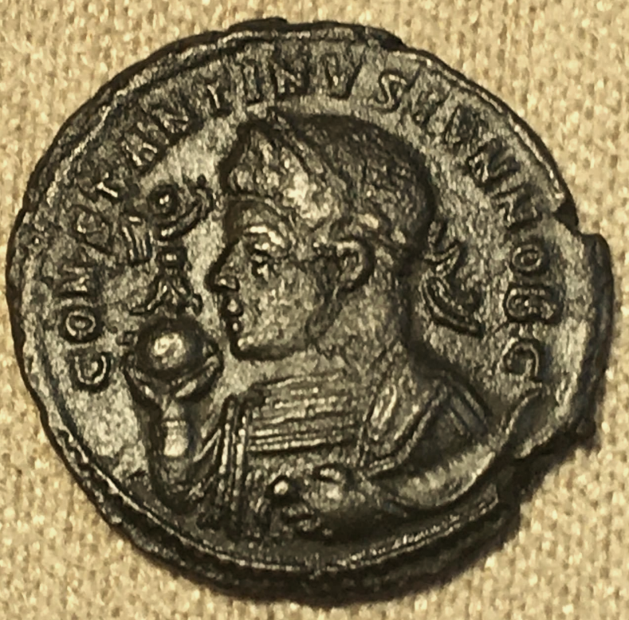 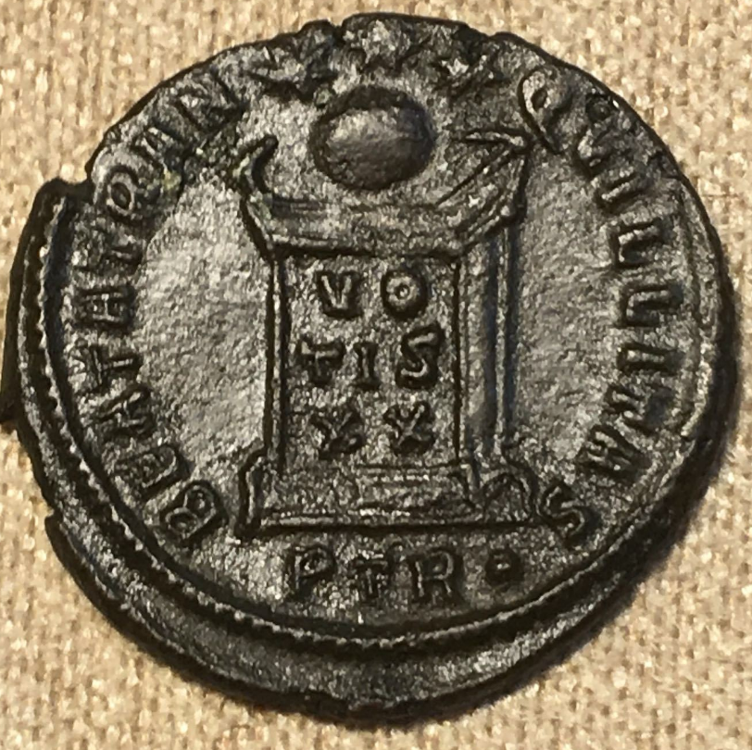

Constantine I 'The Great'- Roman Emperor: 307-337 A.D. -   
Bronze AE3 20mm (3.10 grams) Treveri mint 322-323 A.D.  
Reference: RIC 306 (VII, Trier)   
CONSTANTINVSAVG - Laureate bust left, wearing consular robes, holding scepter with eagle atop.

BEATATRANQVILLITAS Exe: STR• - Altar with globe atop reading VOT/IS/XX; three stars above.

EF/EF+ “EXCEPTIONAL STRIKE, SUPERB GRADE OF PRESERVATION” Chocolate patina.